Week: 11
Experiment: 10
“To prepare glass slides of onion root tips to study stages of mitosis.”
1) Lab Performance (10 Marks):
2) Total Marks (20 Marks):
3) Observation (5 marks):
(Paste 5 Pictures of different stages of mitosis observed in the microscope.)
INTERPHASE:-
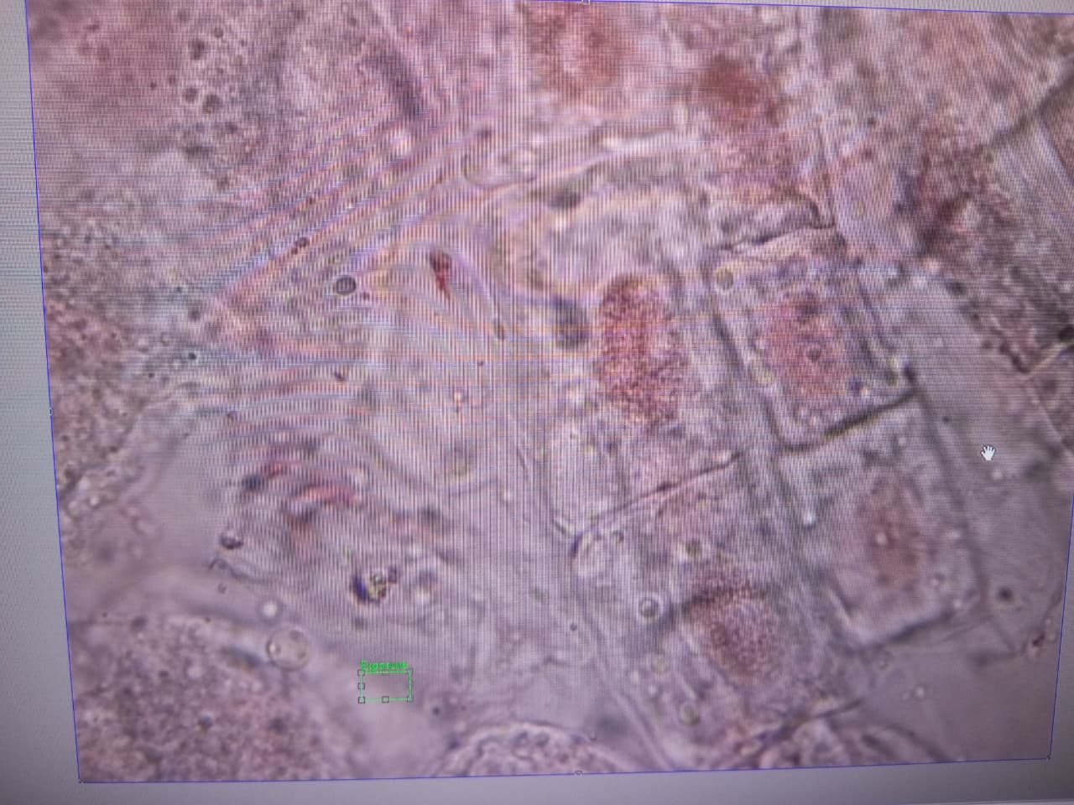

CYTOKYNOSIS:-
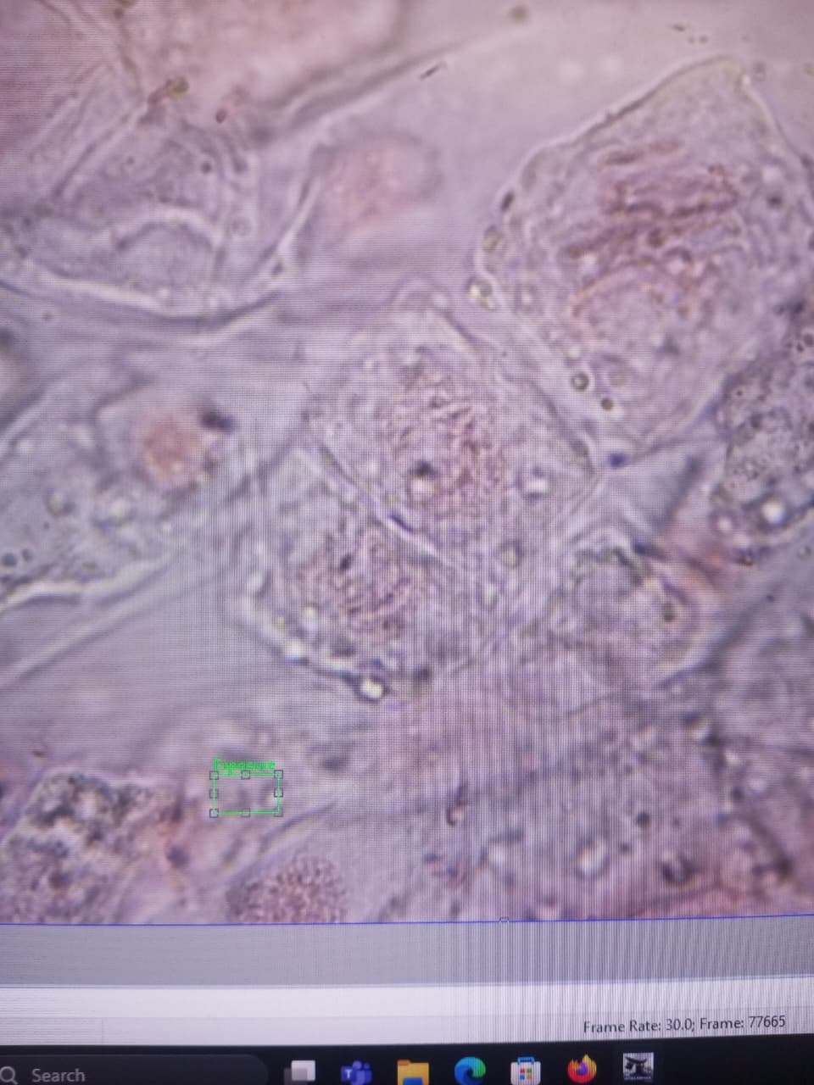

METAPHASE:-
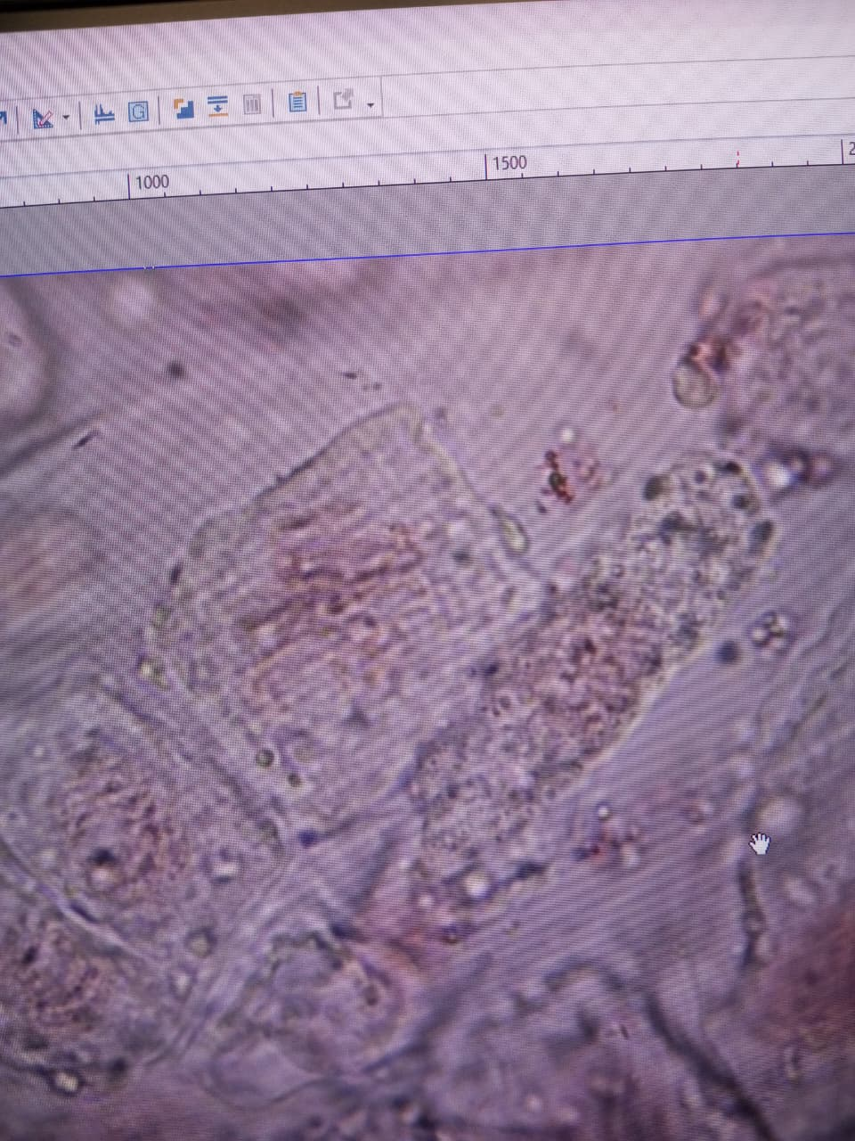

PROPHASE:-
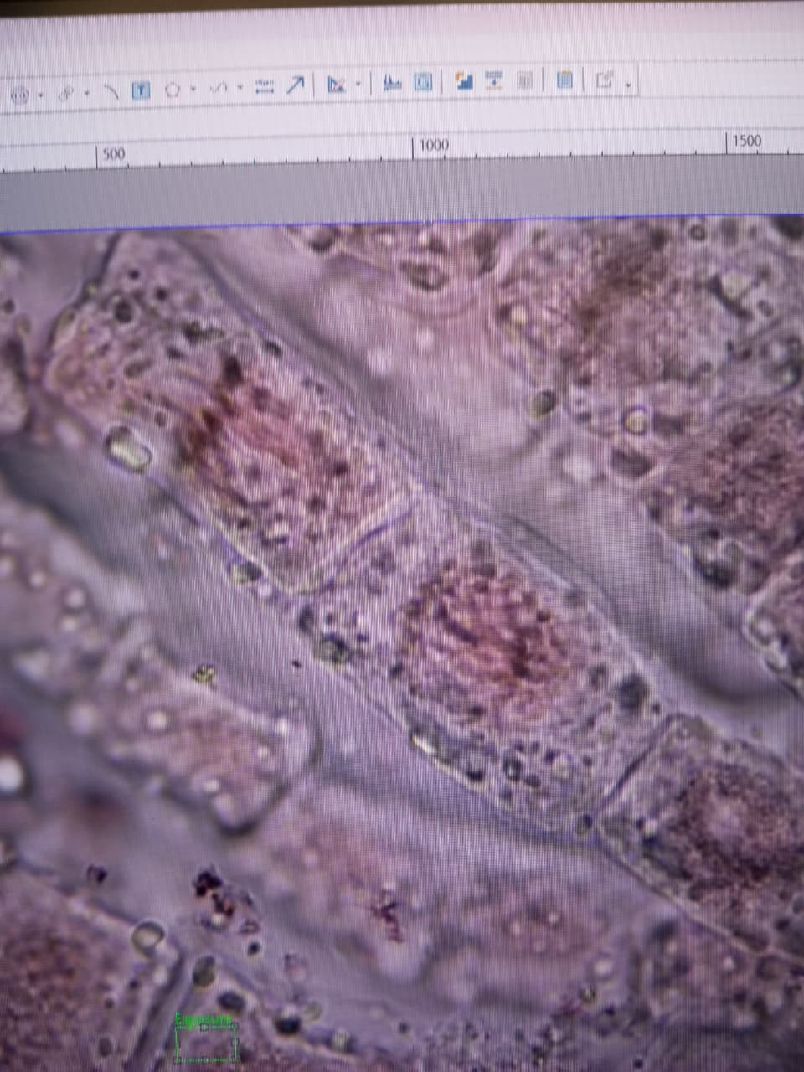

PROPHASE:-

TELOPHASE:-
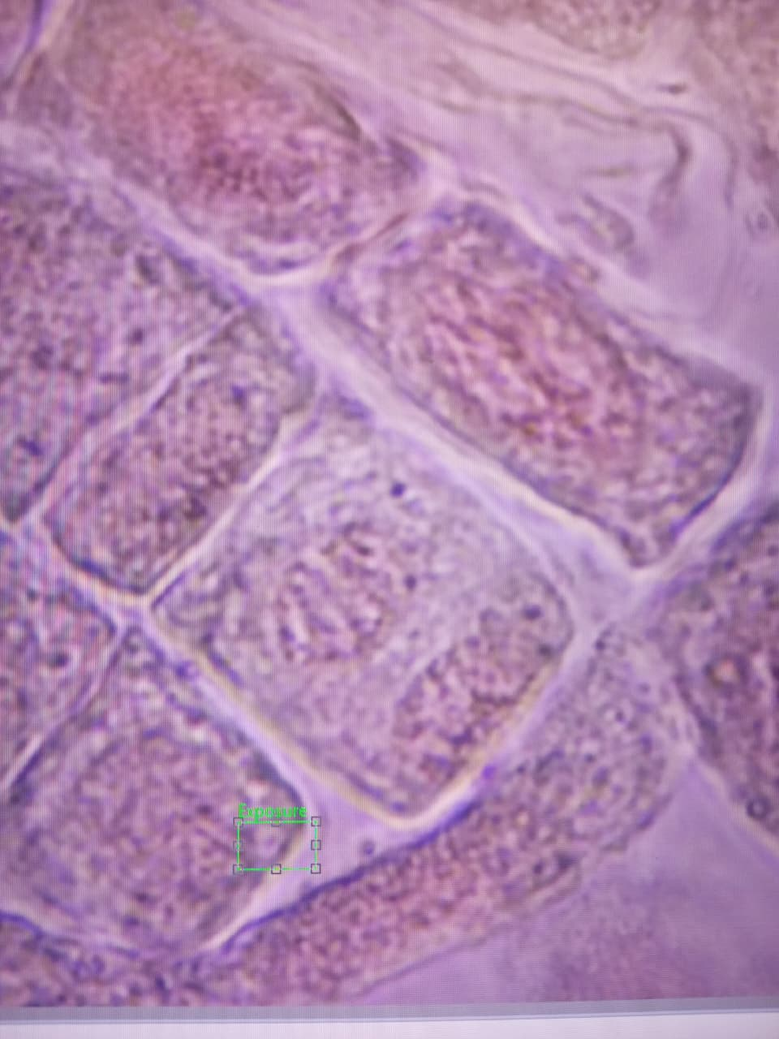

4) Result (5 marks):
• The meristematic region shows numerous cells in various stages of mitosis
• This confirms that root tips are areas of active growth
• Interphase: Longest phase (most cells observed)
• Prophase: Most common mitotic stage (longest mitotic phase)
• Metaphase: Moderate number of cells
• Anaphase: Fewer cells (shortest phase - happens quickly)
• Telophase: less number of cells.
• Mitosis occurs in a predictable sequence - All stages can be identified in order
• Cell division is continuous - Multiple stages visible simultaneously
• Growth occurs through cell division - Active mitosis in meristematic tissue
• Phase duration varies - Longer phases show more cells (interphase and prophase)
5) Labster Simulation (5 marks):
DONE
6) Activity (5 Marks):
Click on the link https://www.biologycorner.com/projects/mitosis/onion_root.html and follow the instructions. Please view each highlighted area in sequence (left to right) and indicate the phase of mitosis and write the name of each phase shown below.
- Highlighted area/Picture 1: Anaphase
- Highlighted area/Picture 2: Metaphase
- Highlighted area/Picture 3: Prophase
- Highlighted area/Picture 4: Telophase
- Highlighted area/Picture 5: Cytokinesis

7) Problems:
Staining was not for long enough so that’s why cell division was not clear under microscope.
Microscope was not good enough/ Stain was not the best.

